Data Communications
AND Networking
Chapter 7



REVISION 6

-------------------------------------------------
Easter eggs
Italic lines indicate that text is directly cloned from text book *
Most of the blueish figures are just screenshots taken from text books
Can you find one more? It’s a SECRET, BTW.

Chapter 7 | Quizzes

What is the position of the transmission media in the OSI or the Internet model?
Below the physical layer.

Name the two major categories of transmission media.
Guided (wired) and unguided (wireless)

How do guided media differ from unguided media?
Guided medias offer a specific path from one device to another but unguided media doesn’t. In unguided media signal distributes through all direction.

What are the three major classes of guided media?
Twisted, Co-axical and Fiber optics.

What is the function of the twisting in twisted-pair cable?
To reduce noise.

What is refraction? What is reflection?
Refrection: If a ray of light traveling through one substance suddenly enters another substance (of a different density), the ray changes direction. It is known as refraction.
Reflection: If the angle is greater than the critical angle, the ray reflects (makes a turn) and travels again in the denser substance, which is known as reflection.

What is the purpose of cladding in an optical fiber?
Cladding has less density than the core, which helps to reflect the light. So it helps to transmit the signal.

Name the advantages of optical fiber over twisted-pair and coaxial cable.
Fiber optic has higher bandwidth, less signal attenuation, immune to electromagnetic interferences as well as lightweight.

How does sky propagation differ from line-of-sight propagation?
In sky propagation, higher-frequency radio waves radiate upward into the ionosphere (the layer of atmosphere where particles exist as ions) where they are reflected back to earth. This type of transmission allows for greater distances with lower output power.
In line-of-sight propagation, very high-frequency signals are transmitted in straight lines directly from antenna to antenna. Antennas must be directional, facing each other, and either tall enough or close enough together not to be affected by the curvature of the earth. Line-of-sight propagation is tricky because radio transmissions cannot be completely focused.

What is the difference between omnidirectional waves and unidirectional waves?

Chapter 6 | Problems

Assume that a voice channel occupies a bandwidth of 4 kHz. We need to multiplex 10 voice channels with guard bands of 500 Hz using FDM. Calculate the required bandwidth.

We need to transmit 100 digitized voice channels using a passband channel of 20 KHz. What should be the ratio of bits/Hz if we use no guard band?
Refs :: https://stackoverflow.com/questions/16548759/ratio-of-bits-hz-of-digitized-voice-channel

In the analog hierarchy of Figure 6.9, find the overhead (extra bandwidth for guard band or control) in each hierarchy level (group, supergroup, master group, and jumbo group).
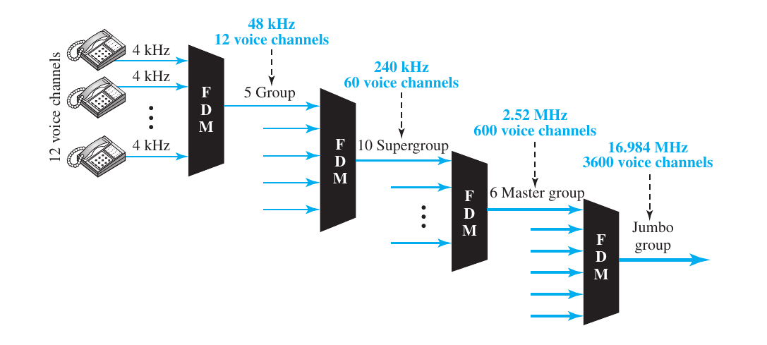
Group = 48 kHz – (4 kHz x 12) = 0 Hz
Super group = 240 kHz – (48 kHz x 5) = 0 Hz
Master group = 2.52 MHz – (240 kHz x 10) = 120 kHz
Jumbo group = 16.984 MHz – (2.52 MHz x 6) = 1.864 MHz

We need to use synchronous TDM and combine 20 digital sources, each of 100 Kbps. Each output slot carries 1 bit from each digital source, but one extra bit is added to each frame for synchronization. Answer the following questions:
a. What is the size of an output frame in bits?
Output frame = 20 x 1 + 1 = 21 bit
b. What is the output frame rate?
Output frame rate = 100,000 frames per second
c. What is the duration of an output frame?
Duration of a frame =
d. What is the output data rate?
Output data rate = 100,000 x 21 = 2100 kbps
e. What is the efficiency of the system (ratio of useful bits to the total bits)?
Efficiency =

Repeat Problem 6-4 if each output slot carries 2 bits from each source.
a. What is the size of an output frame in bits?
Output frame = 20 x 2 + 1 = 41 bit
b. What is the output frame rate?
Output frame rate = 50,000 frames per second
(two bit is taken so we may need extra 2x time, check example 6.9 from text book)
c. What is the duration of an output frame?
Duration of a frame =
d. What is the output data rate?
Output data rate = 50,000 x 41 = 2050 kbps
e. What is the efficiency of the system (ratio of useful bits to the total bits)?
Efficiency =

We have 14 sources, each creating 500 8-bit characters per second. Since only some of these sources are active at any moment, we use statistical TDM to combine these sources using character interleaving. Each frame carries 6 slots at a time, but we need to add 4-bit addresses to each slot. Answer the following questions:
a. What is the size of an output frame in bits?
Frame size = 6 x ( 8 + 4 ) = 72 bits
b. What is the output frame rate?
Output frame rate = 500 frames per second
c. What is the duration of an output frame?
Duration of output frame = 1 / 500 = 0.002 second or, 2 ms
d. What is the output data rate?
Output data rate = 500 x 72 = 36000 bps or 36 kbps
--
I hope output frame duration and data rate should be easy for you to figure out once you know the number of bits per frame and frame rate! So I’ll be skipping these two.

Ten sources, six with a bit rate of 200 kbps and four with a bit rate of 400 kbps, are to be combined using multilevel TDM with no synchronizing bits. Answer the following questions about the final stage of the multiplexing:

a. What is the size of a frame in bits?
If we mulitplex 6 sources of 200 kbps into 3 400 kbps, we will need total 7 (4+3) bits in a frame.
b. What is the frame rate?
Frame rate = 400 frame per second
c. What is the duration of a frame?
Frame duration = 1 / 400,000 = 2.5 µs
d. What is the data rate?
Data rate = 400 x 7 = 2.8 Mbps

Four channels, two with a bit rate of 200 kbps and two with a bit rate of 150 kbps, are to be multiplexed using multiple-slot TDM with no synchronization bits. Answer the following questions:
a. What is the size of a frame in bits?
Here we can divide 200 kbps lines into 4 = 50 kbps lines, and 150 kbps lines into 3 = 50 kbps lines. So we will have total of 7 lines. In this way we will have 7 bits per frame.
b. What is the frame rate?
Frame rate = 50,000 frames per second
c. What is the duration of a frame?
Duration = 1 / frame rate = … (try yourself...)
d. What is the data rate?
Data rate = frame rate x 7 bits = …
I am not sure, feel free to reach me out.

Two channels, one with a bit rate of 190 kbps and another with a bit rate of 180 kbps, are to be multiplexed using pulse-stuffing TDM with no synchronization bits. Answer the following questions:
a. What is the size of a frame in bits?
Size = 2
b. What is the frame rate?
Frame rate = 190,000 frames per second (not sure)
c. What is the duration of a frame? (do yourself)
d. What is the data rate? (do yourself)

Answer the following questions about a T-1 line:
a. What is the duration of a frame?
Duration = 1 / 8000 sec
b. What is the overhead (number of extra bits per second)?
The number of extra bits per second will be 8000 x 1 = 8000 bps.

Show the contents of the five output frames for a synchronous TDM multiplexer that combines four sources sending the following characters. Note that the characters are sent in the same order that they are typed. The third source is silent.
a. Source 1 message: HELLO
b. Source 2 message: HI
c. Source 3 message:
d. Source 4 message: BYE

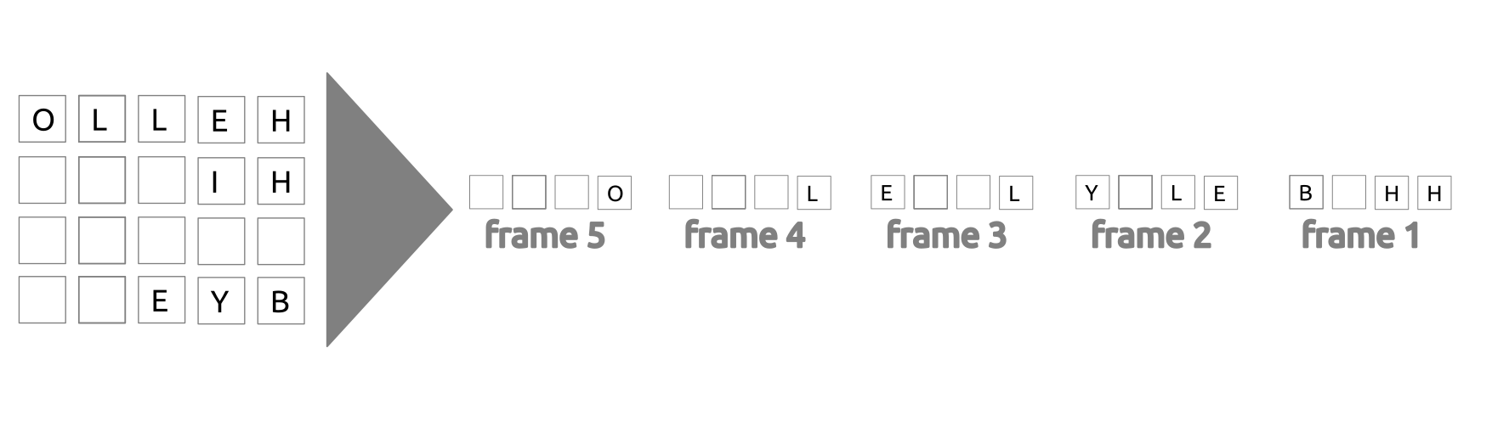
Figure 6.34 shows a multiplexer in a synchronous TDM system. Each output slot is only 10 bits long (3 bits taken from each input plus 1 framing bit). What is the output stream? The bits arrive at the multiplexer as shown by the arrows.
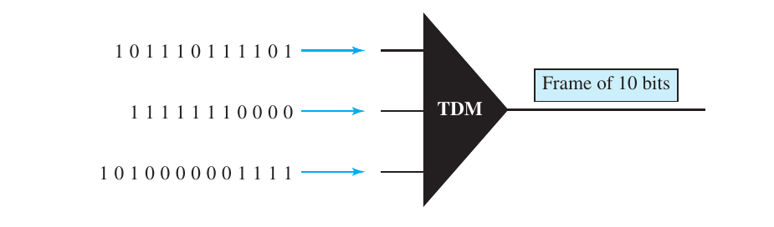
First slot = 1 111 000 101
Second slot = 0 001 110 111
… so on,
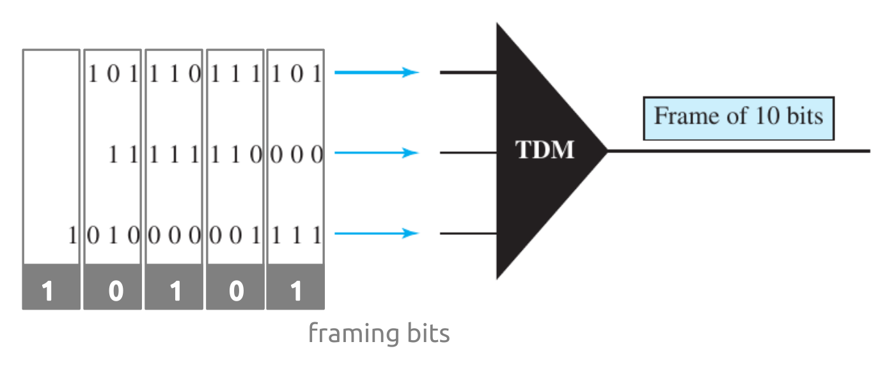
(try yourself)

Figure 6.35 shows a demultiplexer in a synchronous TDM. If the input slot is 16 bits long (no framing bits), what is the bit stream in each output? The bits arrive at the demultiplexer as shown by the arrows.
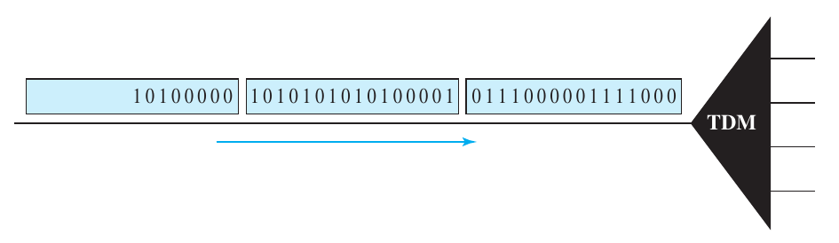
Output line 1 = 1000 0001 0000
Output line 2 = 0111 1010 1010
Output line 3 = 0000 1010
Output line 4 = 0111 1010
refs :: https://static.aminer.org/pdf/PDF/000/274/977/simultaneous_transmission_of_data_fdm_signals.pdf
Also check sadman’s solution, that’s more descriptive!

Answer the following questions about the digital hierarchy in Figure 6.23:
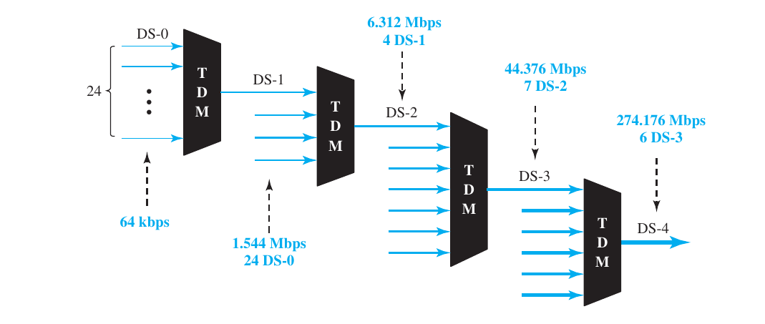
a. What is the overhead (number of extra bits) in the DS-1 service?
DS-1 overhead = 1.544 Mbps – ( 64 kbps x 24 ) = 8000 bps or 8 kbps
b. What is the overhead (number of extra bits) in the DS-2 service?
DS-2 overhead = 6.312 Mbps - ( 1.544 Mbps x 4 ) = 168 kbps (not accurate)
DS-2 overhead = 6.312 Mbps - ( 64 kbps x 24 x 4 ) = 168 kbps
c. What is the overhead (number of extra bits) in the DS-3 service? (try yourself)
d. What is the overhead (number of extra bits) in the DS-4 service? (try yourself)
Results will be 1.368 Mbps (672 times 64 kbps) and 16.128 Mbps (check book, page 171)

What is the minimum number of bits in a PN sequence if we use FHSS with a channel bandwidth of B = 4 KHz and Bss = 100 Khz?
The number of hops = 100 KHz/4 KHz = 25.
So we need log₂25 = 4.64 ≈ 5 bits

An FHSS system uses a 4-bit PN sequence. If the bit rate of the PN is 64 bits per second, answer the following questions:
a. What is the total number of possible channels?
Possible channel =
b. What is the time needed to finish a complete cycle of PN?
For 64 bps,
64 bits can go in 1 second
so, 1 bit can go in 1/ 64 second
and, 4 bit can go in 4/64 or, 0.0625 second
(NOT SURE)

A pseudorandom number generator uses the following formula to create a random series:
N_{i+1=} (5 + 7N_{i}) mod 17 - 1
In which Ni defines the current random number and Ni+1 defines the next random number. The term mod means the value of the remainder when dividing (5 + 7Ni) by 17. Show the sequence created by this generator to be used for spread spectrum.
It’ll generate totally random numbers I guess in between 0 and 15.

We have a digital medium with a data rate of 10 Mbps. How many 64-kbps voice channels can be carried by this medium if we use DSSS with the Barker sequence?
Number of channel =
Most probably, we have to consider chip rate for this question, which I don’t know,
Learn more here,
https://en.wikipedia.org/wiki/Barker_code

--
Pardon my mistakes. Feel free to criticize!

